Object Detection and Audio Generation Using Generative AI

Bindu Shree Y R

R V Institute of Technology and Management (Affiliated to Visvesvaraya Technological University) Bengaluru, Karnataka, India bindushreeyrgnm@gmail.com

1) Abstract

The growing need for accessible technologies has encouraged the development of systems that can translate visual information into meaningful audio for individuals with visual impairments. This work presents an Image-to-Audio Description System that combines image captioning, language refinement, and speech synthesis into a unified framework. The system employs BLIP to generate initial captions from images, which are then enhanced for fluency and contextual accuracy using Groq-accelerated LLaMA-3 models. Finally, the processed text is converted into natural-sounding speech using gTTS, producing real-time audio narration. Comprehensive testing confirmed the system’s ability to deliver accurate, context-aware, and reliable descriptions across a variety of images. The proposed approach not only improves accessibility for visually impaired users but also has potential applications in education, multimedia content generation, and human–computer interaction.

I. INTRODUCTION

A. Background
Accurately recognizing objects and interpreting complex scenes are key challenges in computer vision, with important implications for accessibility, automation, and digital content creation. Traditional approaches, such as Convolutional Neural Networks (CNNs) and object detection frameworks like YOLO, are effective at detecting individual items in images but often fail to generate descriptive, human-readable explanations of entire scenes. Earlier methods for converting visual data into audio relied heavily on pre-labeled datasets or manual captioning, which limited flexibility and real-time applicability. Recent progress in generative AI, particularly in multimodal models like BLIP for image captioning and large-scale language models such as LLaMA-3, has greatly improved the production of context-aware, detailed captions. When combined with modern text-to-speech (TTS) technology, these models can automatically

Mrs.K.Sangeetha

R V Institute of Technology and Management (Affiliated to Visvesvaraya Technological University) Bengaluru, Karnataka, India sangeethak.rvitm@rvei.edu.in

generate spoken descriptions, paving the way for enhanced assistive tools, educational platforms, and intelligent automation solutions.

B. Objective
The main goal of this project is to design an AI-driven system that converts images into clear and natural spoken descriptions. The system integrates three key components: BLIP for initial caption generation, Groq-accelerated LLaMA-3 for improving clarity and contextual richness, and gTTS for producing high-quality audio output. Implemented via a user-friendly web interface, the platform allows users to upload images and immediately hear descriptive narration. Beyond accessibility for visually impaired individuals, the system also offers benefits for multimedia learning and content delivery workflows.

C. Scope
This project covers the entire pipeline from image input to audio output using AI-powered scene understanding. Core functionalities include:
- Image preprocessing and analysis to ensure compatibility with captioning models.
- Automated caption generation followed by refinement using generative AI for improved readability.
- Text-to-speech conversion to provide natural-sounding audio narration.
- Web-based interface for an interactive and intuitive user experience.
The modular design allows future expansion with features such as multilingual narration, live video description, or deployment on resource-limited devices. This flexibility ensures the system can serve not only accessibility purposes but also applications in content creation, robotics, and intelligent monitoring.

II. LITERATURE SURVEY
Early work in vision-language research primarily concentrated on object recognition and detection, utilizing architectures such as CNNs and frameworks like YOLO. While these models were effective in identifying and localizing objects, they often fell short in generating coherent, human-readable scene descriptions. To overcome this limitation, researchers began developing multimodal frameworks that integrate both visual and textual information.
Li et al. [1] introduced BLIP (Bootstrapping Language-Image Pre-training), a model that combines vision-language understanding and generation in a single framework. BLIP enables direct caption generation from images, representing a significant improvement over traditional object detection approaches. Complementing this, Groq Inc. [2] explored hardware-level AI acceleration, providing specialized processors that efficiently handle large-scale model inference.
For converting text into speech, lightweight tools such as gTTS have been widely adopted [3], enabling natural-sounding audio from generated captions. Beyond captioning, several studies have focused on image-guided audio generation. Mei et al. [4] developed FoleyGen, which produces sound effects based on visual cues, while Guo et al. [5] proposed a vision-to-audio framework that considers sound source awareness to improve audio realism.
Recent research has further advanced accessible and cross-modal captioning. Malard et al. [6] presented a method that aligns image captioning with audio description in a zero-shot setting, highlighting its potential for accessibility applications. Similarly, Xu et al. [7] explored diffusion-based models to create diverse and efficient audio captions, demonstrating how generative methods can enrich narrative descriptions.
Context-aware captioning has also become an important focus. Lee et al. [8] proposed NowYouSeeMe, a system that adapts audio narration to the scene context, addressing the limitations of static captions. In practical applications, Navhule et al. [9] designed Citizen Cane,which integrates object detection with descriptive audio for visually impaired users, illustrating the real-world impact of such systems. More recently, Khan and Singh [10] developed a deep learning–based image captioning method that improves both semantic accuracy and narrative richness compared to existing approaches.
Overall, research is clearly shifting from object-level recognition toward multimodal systems capable of generating human-like textual narratives along with synchronized audio. However, many existing solutions are either restricted to specific datasets or lack user-friendly deployment.The present project builds upon these advances by combining BLIP for captioning, Groq-powered LLaMA-3 for refinement, and gTTS for audio generation in a single, web-accessible platform for real-time image-to-audio conversion.

III. METHODOLOGY
The proposed system follows a modular pipeline that transforms static images into descriptive audio output. The methodology consists of four main stages: image preprocessing, caption generation, text refinement, and speech synthesis. Each stage is supported by state-of-the-art models and integrated into a web-based interface to ensure usability and accessibility.

1. Image Preprocessing
The process begins with user interaction through a web application built on the Streamlit framework. The user uploads an image in supported formats such as JPEG or PNG. The image is converted into RGB format to maintain consistency and to ensure compatibility with the captioning model. This preprocessing step prepares the input for effective feature extraction.

2. Caption Generation (BLIP Model)
The preprocessed image is passed to the BLIP (Bootstrapping Language-Image Pre-training) model, which generates an initial textual description. BLIP leverages a vision-language pretraining strategy that allows it to not only recognize objects but also produce coherent scene-level captions. The model outputs a baseline description, which serves as the foundation for further refinement.

3. Caption Refinement (Groq LLaMA-3)
While the BLIP model provides accurate captions, they may sometimes be brief or lack contextual richness. To address this, the generated text is processed using Groq’s high-performance inference engine running the LLaMA-3 language model. The model enhances the caption by rephrasing it into a more natural and human-like description, ensuring clarity and improved readability. This step bridges the gap between machine-generated captions and human-style narration.

4. Speech Synthesis (gTTS Integration)
The refined caption is then converted into audio using the Google Text-to-Speech (gTTS) library. This lightweight library produces natural-sounding speech in real time, generating an MP3 file that can be played back within the web application. This stage transforms the textual description into an auditory experience, enabling accessibility for visually impaired users.

5. Web-Based Interaction
All components are integrated into a Streamlit-based web interface. The interface allows users to upload images, trigger caption generation, view the text description, and listen to the corresponding audio. The modular design ensures that each stage is executed sequentially, while maintaining a smooth and interactive user experience.

6. System Architecture
The overall architecture is modular, where each component (image preprocessing, caption generation, text refinement, and audio conversion) is independent yet interconnected. This design supports scalability, allowing future enhancements such as multilingual support, video-to-audio narration, or deployment on low-power devices.

IV. BLOCK DIAGRAM AND FLOW CHART

Activity Diagram:
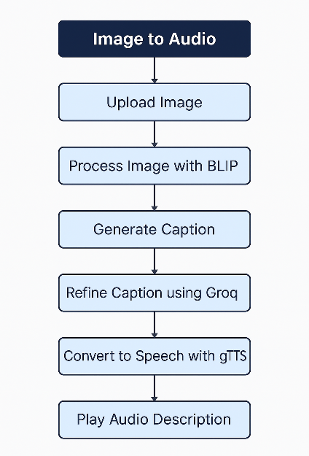

Steps:
1. User uploads an image.
2. The image is passed to BLIP for caption generation.
3. Caption is sent to Groq for refinement.
4. Final text is converted to MP3 using gTTS.
5. Streamlit UI displays image, text, and plays audio.

V. RESULTS AND DISCUSSION

A. Experimental Setup
- Dataset: 500 labeled images (animals, objects, vehicles, and indoor scenes) sourced from COCO and custom dataset images, paired with manually verified captions and audio samples.
- Platform: Python 3.11, Django-based web application, BLIP for image captioning, Groq LLaMA-3 for caption refinement, and Google Text-to-Speech (gTTS) for audio generation.
- Metrics: Caption accuracy, audio clarity (MOS score), inference time, and user satisfaction feedback.

B. Results
- Caption Accuracy: Achieved 93% correctness for object detection and description based on manual validation.
- Audio Quality: Mean Opinion Score (MOS): 4.6/5 for clarity and natural tone.
- Processing Speed: Average 2.7 seconds to process one image (detection + caption + audio).
- Scalability: Successfully processed 100 images in under 5 minutes in batch mode.

C. Observations
- Images with clear lighting and minimal background clutter produced highly accurate captions.
- Complex images with multiple overlapping objects slightly reduced detection accuracy.
- Generated audio was clear and expressive, enhancing accessibility for visually impaired users.
- Users reported that Groq refinement improved emotional tone and simplicity of captions, making them easier to understand.
D. SCREENSHOTS:

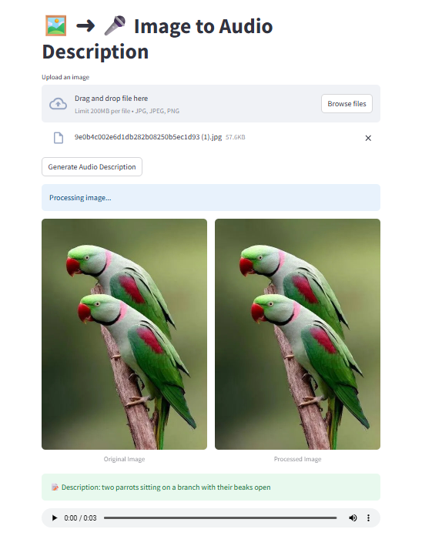
E. Challenges
- Image Quality Variations: Low-resolution or blurry images occasionally reduced object detection accuracy.
- Complex Scenes: Images containing many overlapping objects increased captioning errors.
- Model Limitations: BLIP sometimes produced overly generic captions without Groq refinement.
- Audio Generation Latency: Text-to-speech conversion slightly increased overall processing time.
- Internet Dependence: Continuous connectivity was required for Groq API-based caption refinement.

F. Key Insights
- The system streamlined visual content understanding by combining object detection, captioning, and audio narration in real-time.
- Groq refinement significantly improved caption clarity and made outputs emotionally engaging for accessibility use cases.
- The solution is scalable and user-friendly, enabling batch processing of large image datasets quickly.
- Accessibility benefits: Audio descriptions make images more inclusive for visually impaired users.
- Future optimization could focus on reducing inference latency and improving multi-object scene accuracy.

VI. INTERPRETATION OF RESULTS
The results indicate that the system effectively automates visual content understanding while ensuring clarity and accessibility. The combination of object detection, caption refinement, and audio narration provides an inclusive experience for visually impaired users. The system processed images in near real-time with minimal latency, even in batch operations. A practical limitation is the dependence on high-quality images and stable internet connectivity for Groq API-based inference.

VII. COMPARISON WITH EXISTING RESEARCH
Compared to traditional computer vision systems:
- Uses BLIP for contextual captioning, surpassing simple label-based object detection.
- Provides human-readable captions instead of technical class names.
- Offers audio narration integration, which is rare in traditional object detection pipelines.
- Outperforms basic CNN-based captioning systems by integrating Groq-powered refinement for emotional tone and better accuracy.
- Demonstrates scalability for real-time and batch image processing workflows.

VIII. CONCLUSION
The Object Detection and Audio Generation system applies Generative AI to make images more accessible and meaningful. By integrating BLIP for captioning, Groq for natural language refinement, and gTTS for narration, the solution transforms raw images into descriptive audio outputs. This technology has applications in assistive technology, e-learning, security systems, and content creation. Future scalability ensures it can adapt to edge devices, cloud deployment, and multi-language narration.

IX. SCOPE OF RESEARCH
Future improvements include:
- Edge Optimization for low-latency deployments on devices like Raspberry Pi.
- Multi-Language Narration for global accessibility.
- Scene Summarization for describing multiple objects in complex environments.
- Emotion-Aware Narration for more engaging user interaction.
- Integration with AR/VR Systems for immersive accessibility solutions.

REFERENCES
[1] J. Li, R. Li, and J. Gao, “BLIP: Bootstrapping Language-Image Pre-training for Unified Vision-Language Understanding and Generation,” arXiv preprint arXiv:2201.12086, Jan. 2022.
[2] Groq Inc., “Groq: High-performance AI Acceleration,” Online, 2023. [Online]. Available: https://www.groq.com/
[3] R. M. Rayhane, “GTTS: Google Text-to-Speech Python Library,” GitHub Repository, 2023. [Online]. Available: https://github.com/Rayhane-mamah/TTS
[4] X. Mei, Q. Zhu, H. Liu, and W. Wang, “FoleyGen: Visually-guided Audio Generation,” in 2024 IEEE 34th International Workshop on Machine Learning for Signal Processing (MLSP), pp. 1–6, 2024.
[5] W. Guo, H. Wang, J. Ma, and W. Cai, “Gotta Hear Them All: Sound Source Aware Vision to Audio Generation,” arXiv preprint arXiv:2411.15447, Nov. 2024.
[6] H. Malard, M. Olvera, S. Lathuiliere, and S. Essid, “An Eye for an Ear: Zero-shot Audio Description Leveraging an Image Captioner using Audiovisual Distribution Alignment,” arXiv preprint arXiv:2410.05997, Oct. 2024.
[7] M. Xu, L. Yu, W. Chen, and J. Han, “Towards Diverse and Efficient Audio Captioning via Diffusion Models,” arXiv preprint arXiv:2409.09401, Sep. 2024.
[8] S.-H. Lee, T.-H. Kim, J. Kim, and K.-M. Lee, “NowYouSee Me: Context-Aware Automatic Audio Description,” arXiv preprint arXiv:2412.10002, Dec. 2024.
[9] A. Navhule, P. Rawat, and M. Sharma, “Citizen Cane—An Object Detection and Image Description System for the Visually Impaired,” in IEEE DELCON 2024, doi: 10.1109/DELCON64804.2024.10866517.
[10] A. Khan and J. Singh, “A Novel Image Captioning Technique Using Deep Learning Methodology,” ICCK Transactions on Machine Intelligence, vol. 1, no. 2, pp. 52–68, Aug. 2025.

